**PostgreSQL – Query result Assignment**

**Database Name:** Chinook

**Query 1:**

SELECT sum("Invoice"."Total") as TotalSales FROM "Invoice";

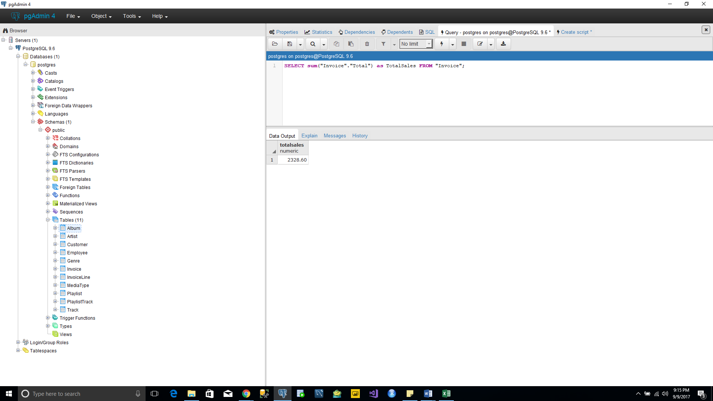

**Query 2:**

select "BillingCountry" as CountryName, sum("Total") as TotalSales, Dense_Rank() over(order by sum("Total") desc) as CountryRank from "Invoice" group by "BillingCountry";

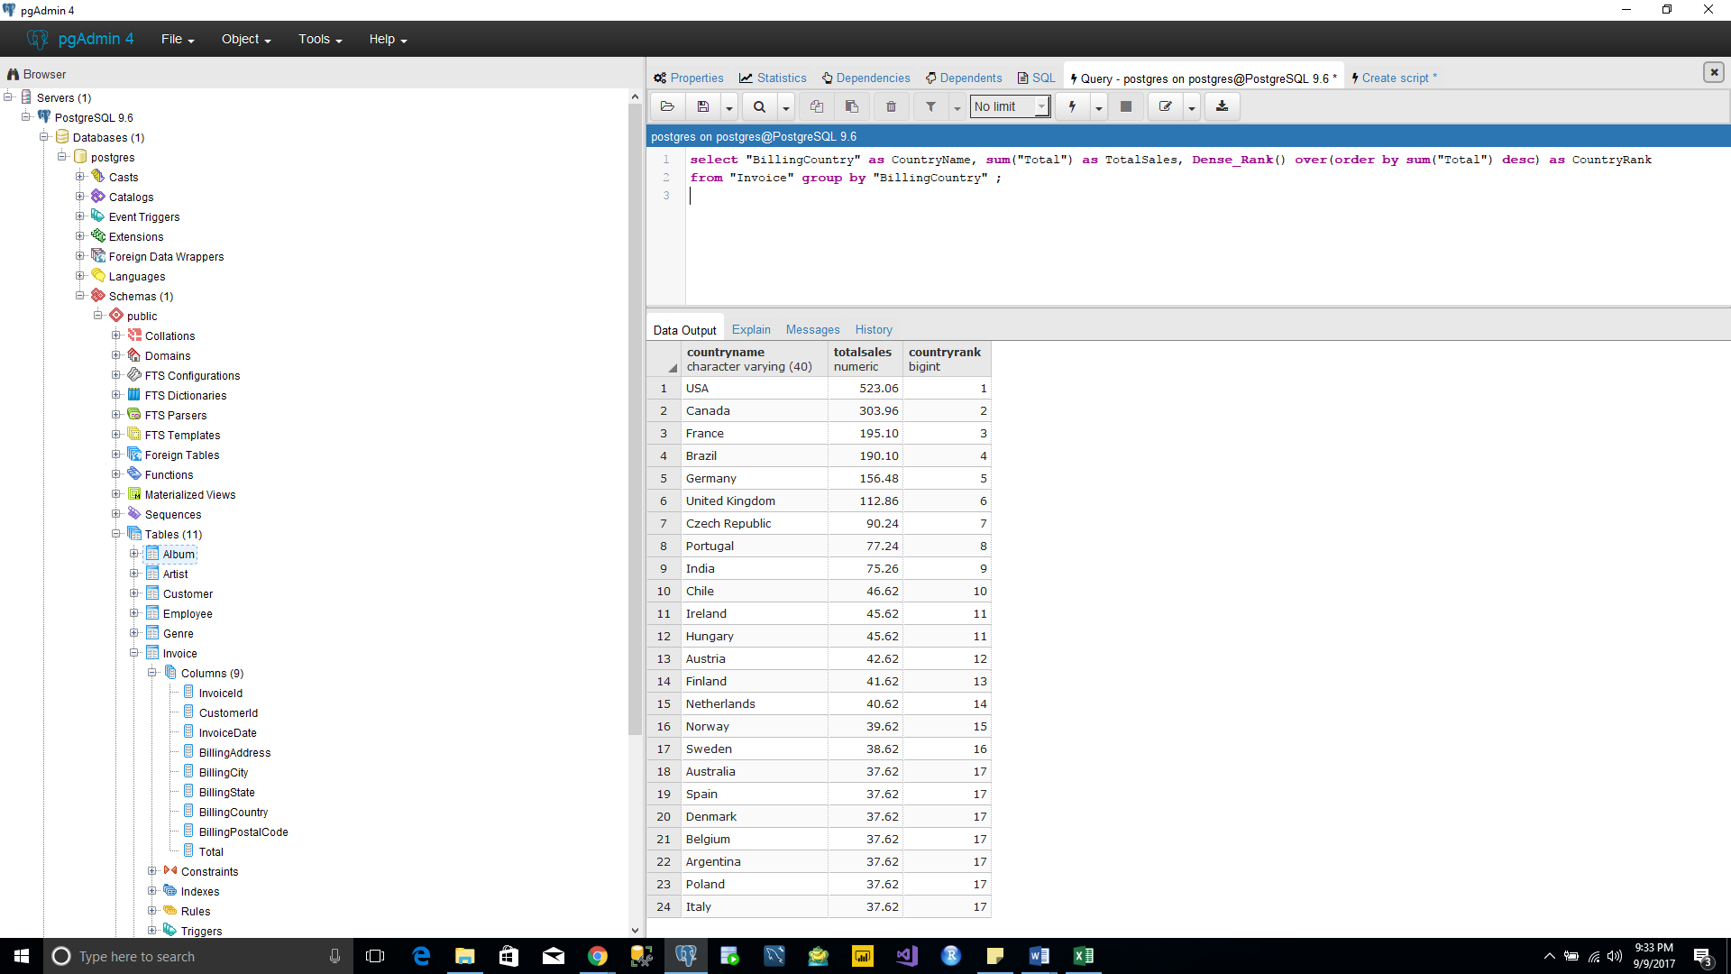

**Query 3:**

select "BillingCountry" as Country, "BillingState" as state, "BillingCity" as City,

sum("Total") as TotalSales from "Invoice" group by "BillingCountry","BillingState","BillingCity" order by sum("Total") desc;

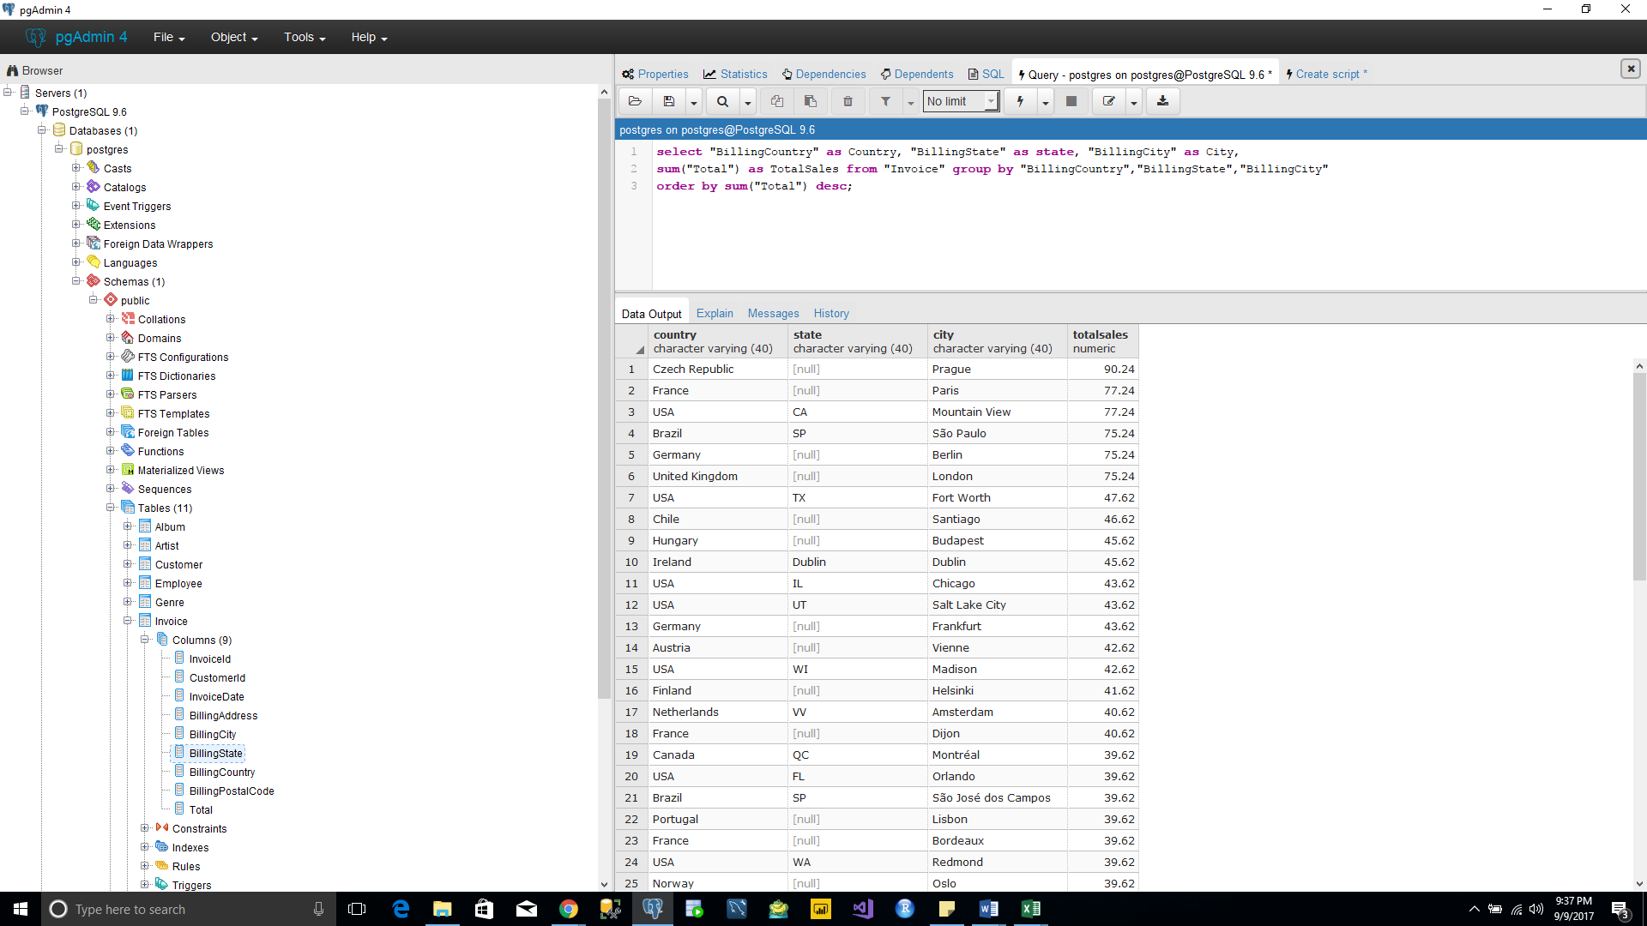

**Query 4:**

select concat(cus."FirstName" || ' '|| cus."LastName") as CustomerName, sum(inv."Total") as TotalSales, DENSE_RANK() over (order by sum(inv."Total") desc) as CustomerRank

from "Invoice" inv inner join "Customer" cus on inv."CustomerId" = cus."CustomerId"

group by concat(cus."FirstName" || ' '|| cus."LastName");

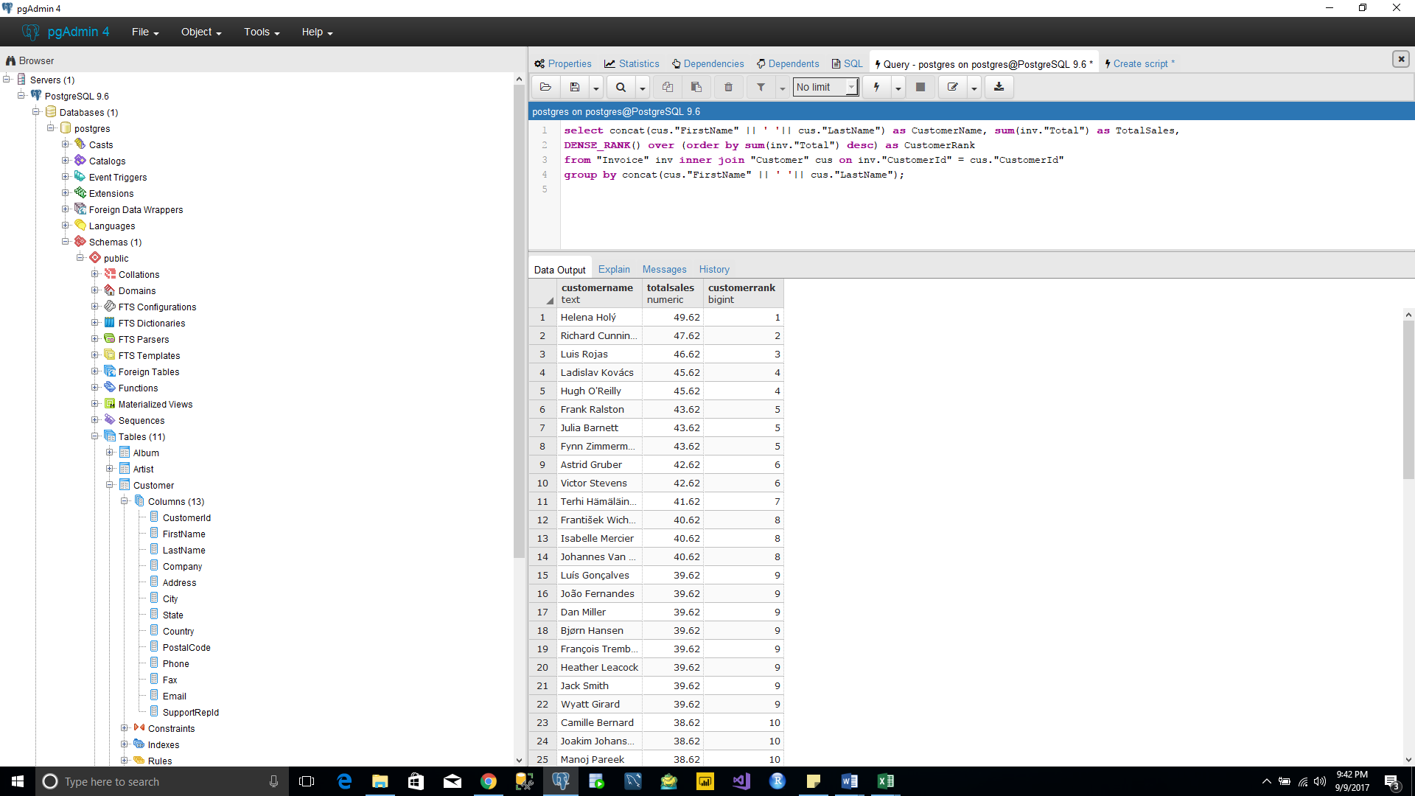

**Query 5:**

select ar."Name" as ArtistName, sum(iv."Total") as TotalSales, DENSE_RANK() over(order by sum(iv."Total") desc) as ArtistRank from "Invoice" iv inner join "InvoiceLine" il on iv."InvoiceId" = il."InvoiceId" inner join "Track" tr on il."TrackId" = tr."TrackId" inner join "Album" al on tr."AlbumId" = al."AlbumId" inner join "Artist" ar on al."ArtistId" = ar."ArtistId" group by ar."Name" order by sum(iv."Total") desc;

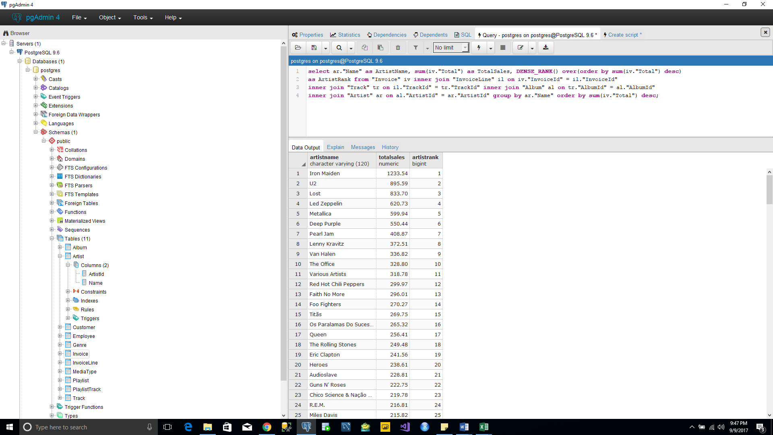

**Query 6:**

select ar."Name" as ArtistName, al."Title" as AlbumName, sum(iv."Total") as TotalSales

from "Invoice" iv inner join "InvoiceLine" il on iv."InvoiceId" = il."InvoiceId"

inner join "Track" tr on il."TrackId" = tr."TrackId" inner join "Album" al on tr."AlbumId" = al."AlbumId" inner join "Artist" ar on al."ArtistId" = ar."ArtistId" group by ar."Name", al."Title" order by sum(iv."Total") desc;

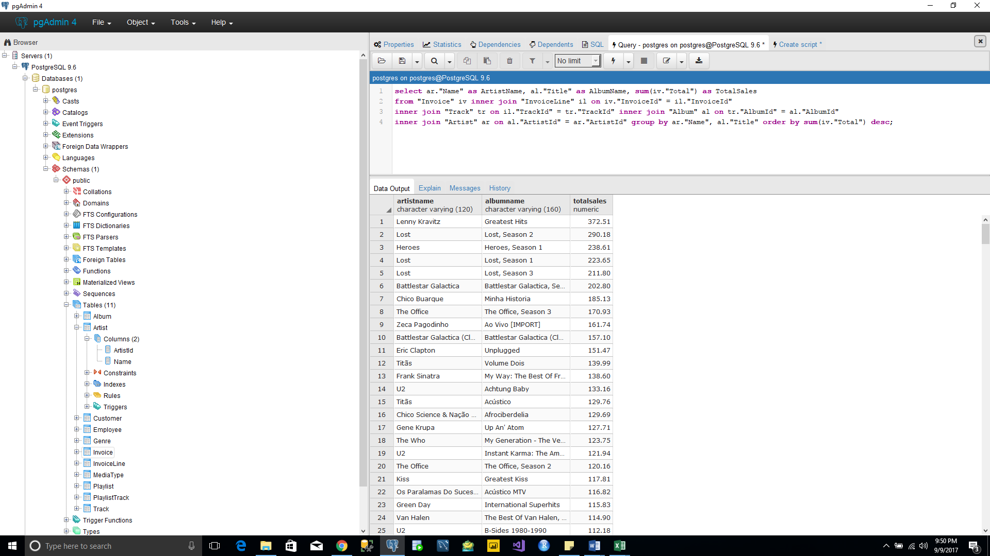

**Query 7:**

select CONCAT (emp."FirstName" || ' ' || emp."LastName") as EmployeeName, sum(inv."Total") as TotalSales from "Invoice" inv inner join "Customer" cus on inv."CustomerId" = cus."CustomerId" inner join "Employee" emp on cus."SupportRepId" = emp."EmployeeId" group by CONCAT (emp."FirstName" || ' ' || emp."LastName")

order by sum(inv."Total") desc;

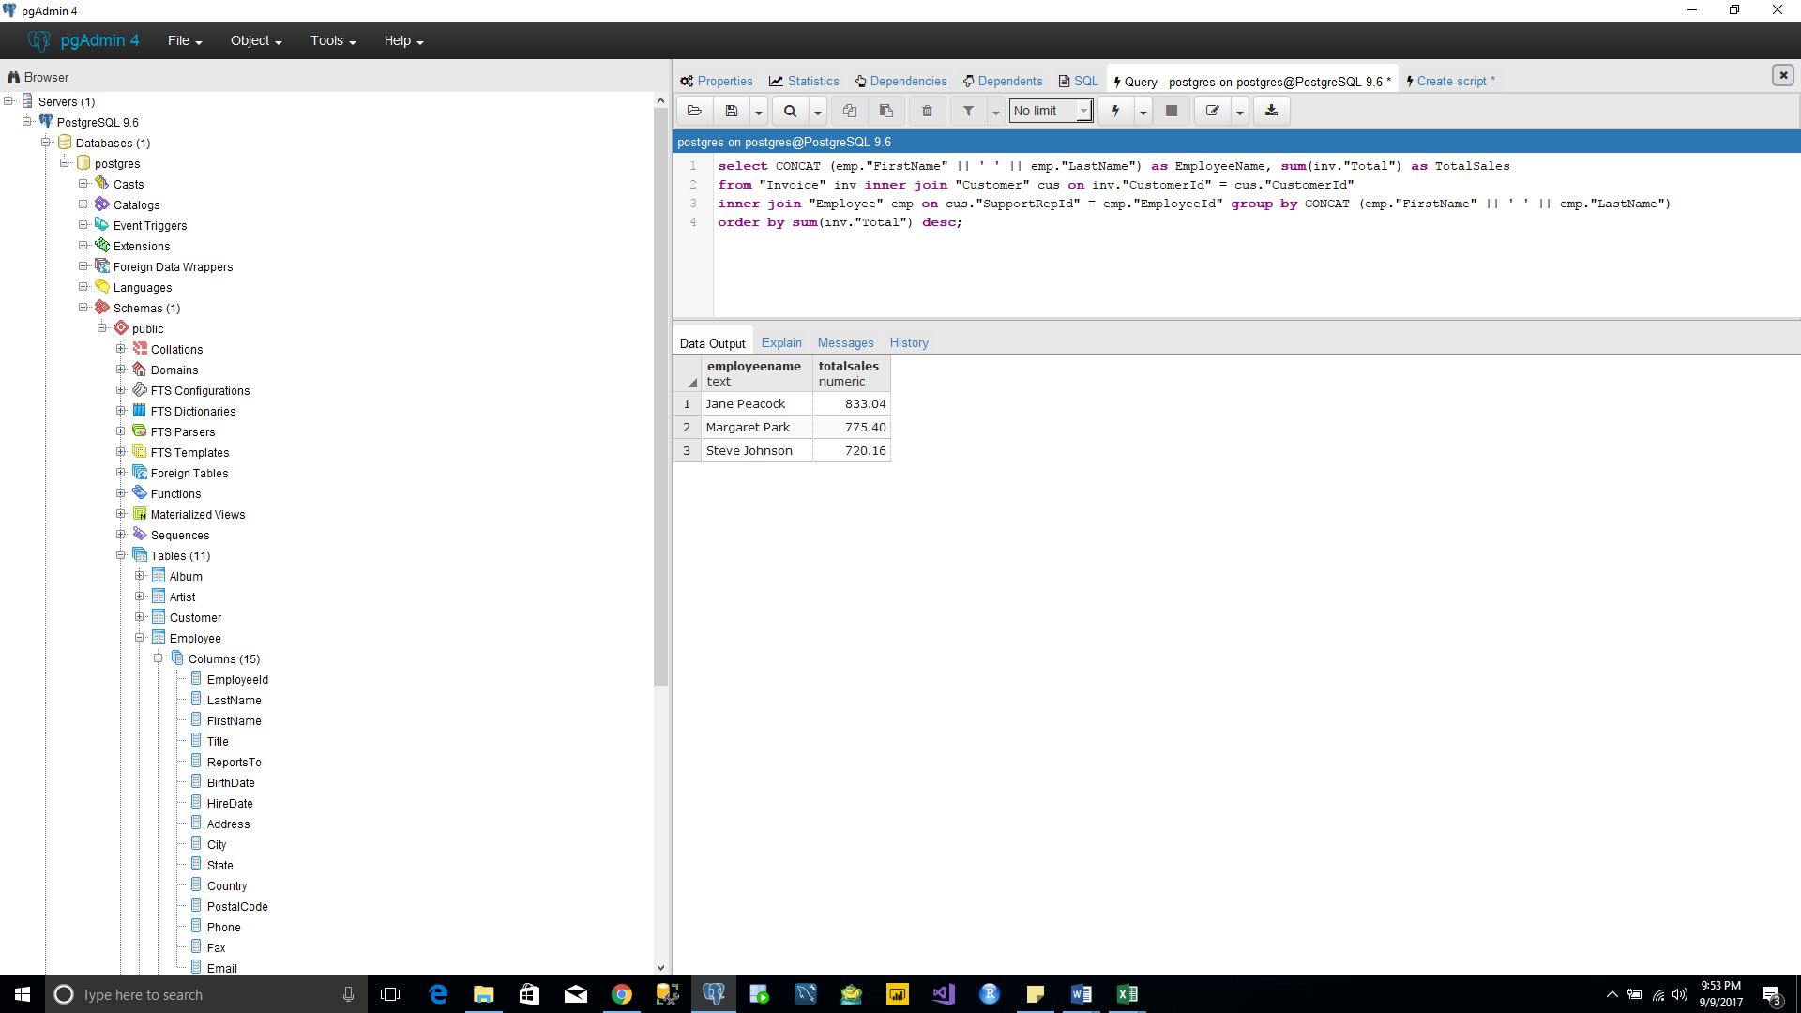

**Query 8:**

select m."Name" as MediaTypeName, count(t."TrackId") as TrackBought, sum(t."UnitPrice") as Cost from "MediaType" m inner join "Track" t on m."MediaTypeId" = t."MediaTypeId" group by m."Name";

